PRESS RELEASE
EMBARGOED FOR IMMEDIATE RELEASE
Yuri Williams, Founder
AFutureSuperHero and Friends
562-999-1304
AFutureSuperHero@gmail.com
www.afuturesuperhero.org

AFUTURESUPERHERO & FRIENDS CELEBRATE CHILDREN WITH SPECIAL NEEDS/DISABILITES IN DRIVE-THRU GIVEAWAY EVENT

Deadpool Ross will be giving away backpacks with back to school supplies to children with disabilities and special needs

Long Beach, CA, 9/5/2020 – AFutureSuperHero and Friends is excited to announce its latest venture with Tichenor Clinic – a Drive-Thru Backpack Giveaway!

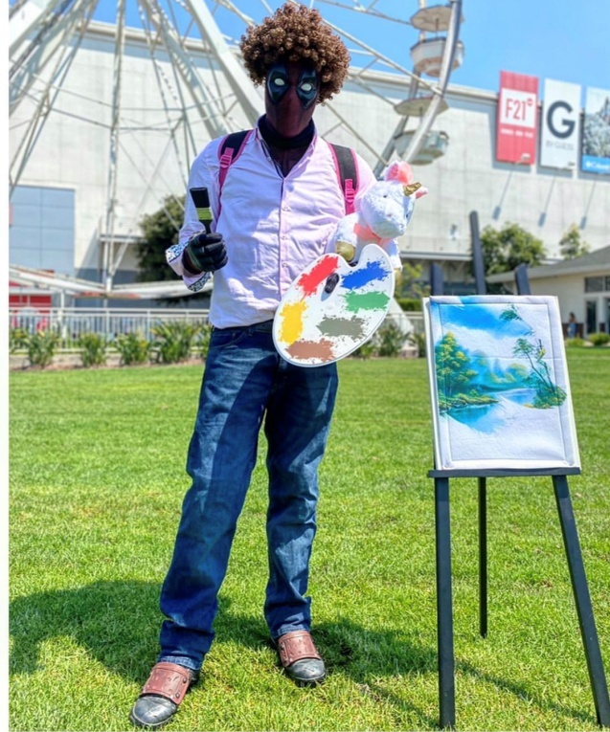
Arranged exclusively for children with disabilities and special needs, the initiative is a welcome reprieve from the doom and gloom of the pandemic and is sure to spread smiles in a community that is often ignored in other mainstream giveaway events.

The Back to School Drive-Thru event will be hosted at the Tichenor Clinic for Children on 5th September from 10 AM to 1 PM. AFutureSuperHero and Friends will be giving away free backpacks that carry back to school supplies at the event.

What’s more, the giveaways will be handed out by none other than Deadpool Ross – a sight that’s sure to have every child squealing in anticipation! Participants can visit the Company’s website to register.

To ensure the safety of all those present, every adult and child at the event will be required to observe COVID-19 safety guidelines and must wear masks. Volunteers at the event will also be ensuring that all attendees observe social distancing.

Yuri Williams, the Founder of AFutureSuperHero and Friends, spoke about the collaboration and said, “I am deeply thankful to the organizers at Tichenor Clinic for helping us arrange this initiative. It is our way of reaching out to all kids with special needs and disabilities and telling them that we see you, we hear you, and we care for you. I hope that every child that attends the event walks away with a smile on their face. I would also like to take a moment to appeal to everyone out there - It’s a difficult time for us all, so look after yourselves and help out where you can. That’s the only way we can get through this. ”

About AFutureSuperHero and Friends
AFutureSuperHero and Friends is a non-profit organization committed to helping the underprivileged and easing their suffering. Since its inception, the organization has completed several projects including blood drives, toy drives, and providing food and clothes to the homeless.
Address: 4470 Atlantic Ave #7843 Long Beach, CA 90807 | Phone: 562-999-1304
About Tichenor Clinic for Children:
The Tichenor Clinic provides rehabilitative and enrichment services to disabled children. It is known for developing metal implants for joint replacement in children.
Address: 1660 Termino Ave Long Beach, CA | Phone: 562-597-3696
To learn more, visit https://www.afuturesuperhero.com/ and https://www.tichenorclinic.org/

